W-12
YEAR 9 SCIENCE
PHYSICAL SCIENCES - REVISION

Heat

1. Define the following terms.

(a) temperature (b) heat (c) thermal energy

2. Explained how heat is transferred in the following.

(a) A piece of copper wire that is heated at one end.
(b) A pot of warm water that is being heated.
(c) A room with a small gas heater at floor level.

3. Metals have a very high thermal conductivity while gases are very low. Explain this difference.

4. Some very expensive cookware has copper bottoms on all the pots and pans. Suggest a reason for this.

5. Sports people who injure themselves are advised to put ice or a cold pack immediately on the injury to limit any internal bleeding. Why does the ice feel cold on the skin?

6. Radiators on cars, trucks and other engines are painted black and have lots of very fine "fins" which allow the air to pass through. How do these two features make the radiator an efficient cooling device for the water carrying heat away from the engine?

7. Explain how a vacuum flask keeps coffee hot. (Refer to how it uses conduction, convection and radiation in its design.)

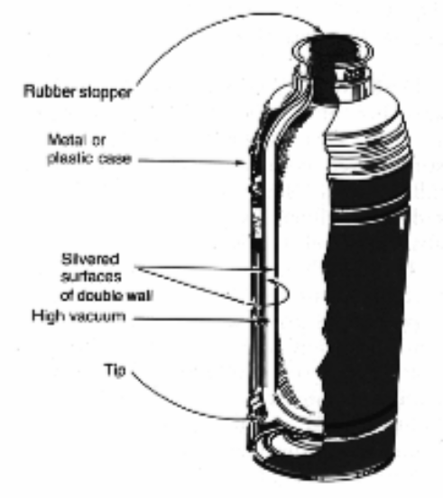

8. Himalayan rabbits have black feet, ears and noses. Why is this a good adaptation for this animal?

9. A dark coloured and woolly jumper is a must for some people in our winter season. Give two reasons why such a jumper keeps a person warm.

Sound

1. (a) What causes a sound to be made?
(b) Can sound be heard in space? Explain your answer.

2. You can hear a clock ticking from 1.00 m away. Do the particles of the air move from the clock to
your ear? Explain your answer.

3. (a) Sound waves are called longitudinal waves. Describe how the particles of the medium move in
this type of wave.
(b) Draw a simple diagram to show how a tuning fork forms a sound wave.
(c) What is a compression and rarefaction?

4. (a) How do the particles move in a transverse wave? Give an example of this wave.
(b) Draw a displacement - distance graph to show the following. Make sure you give appropriate
scales and labels.

amplitude = 5.00 cm
wavelength = 10.0 cm

5. Define the following terms.

(a) wavelength
(b) frequency
(c) period
(d) amplitude

6. Why does sound travel faster in a solid like steel when compared to the speed in air?

7. Draw simple wave drawings to show the following.

(a) A loud sound with two wavelengths shown.
(b) A soft sound with the same frequency as part (a).
(c) A soft sound with twice the frequency of the sound in part (a).

8. Why is it difficult to be heard by your friend if you are shouting into the wind?

9. What is the difference between music and noise?

10. (a) What units are used to measure sound level?
(b) What level is considered dangerous to hearing?
(c) Name two possible causes of hearing damage.

11. (a) Describe the function of the following parts of the ear.

(i) pinna
(ii) eardrum
(iii) auditory nerve
(iv) hammer, anvil and stirrup
(v) eustachian tube
(vi) semi-circular canals
(vii) cochlea

(b) Label the following diagram of the ear.

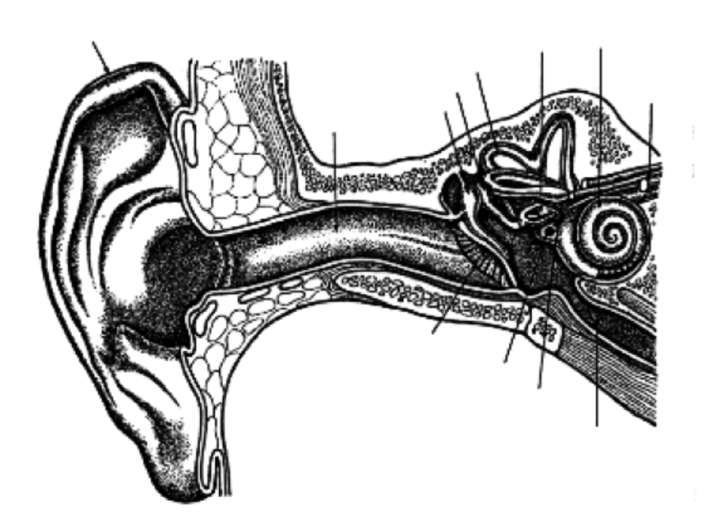

Light

1. (a) How would you describe light - what is it?
(b) Does light need a medium to travel in? How do you know?

2. (a) List the parts of the electromagnetic spectrum in order.
(b) Give a use or characteristic for each part.

3. (a) What are the Laws of Reflection?
(b) Draw a simple diagram to show it.

4. What is the difference between a real image and a virtual image?

5. Draw simple diagrams to show the difference between regular and diffuse (irregular) reflection.

6. Define the Laws of Reflection. Use a simple diagram to help your explanation.

7. Complete the following ray diagrams.
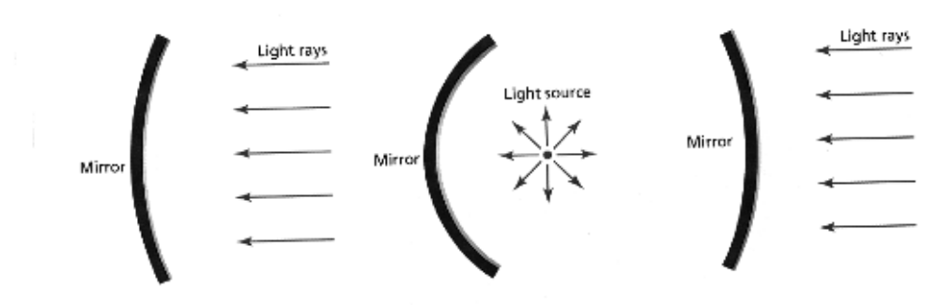

8. (a) Define the term refraction.
(b) Will a light ray refract when it enters a new medium at right angles (along the normal)?
(c) If a light ray enters a new medium where it speeds up, does it refract towards or away from
the normal?

9. Complete the following ray diagrams to show the path taken through the glass prisms.

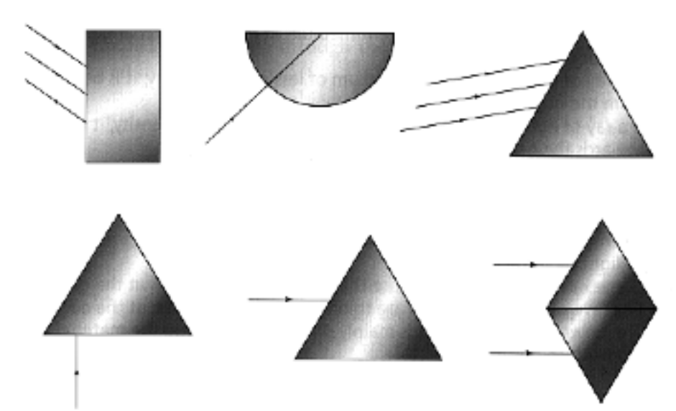

10. (a) If a person on a jetty wishes to spear a fish swimming in the water (not directly below), where should they aim?
(b) Draw a simple diagram to show this situation.

11. (a) If an object is placed a long way from a convex lens, what type of image is formed?
(b) Where should an object be placed when a convex lens is used as a magnifying glass?

12. (a) Label the parts of the eye on the diagram below.

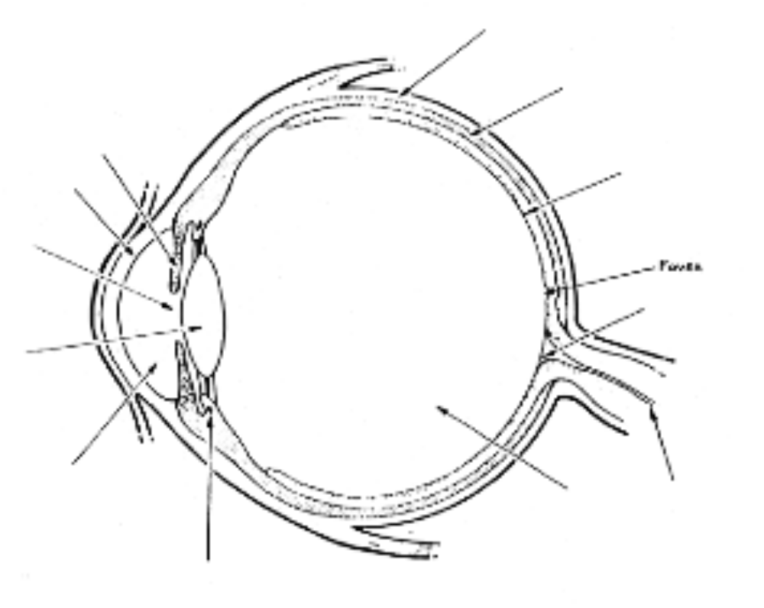

(b) Give the major function for each part.

13. Describe how the lens of the eye changes to focus on a close object and a distant object.

14. (a) With the aid of simple diagrams, explain how a person is affected by short sight (myopia) and long sight (hypermetropia).
(b) How is each problem overcome?

15. What is the blind spot in the eye?

